15.76:

a) The new tension 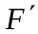in the wire is

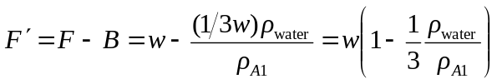

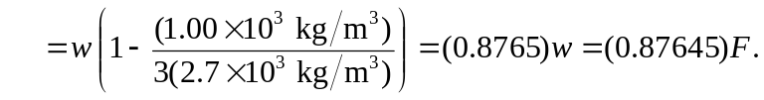

The frequency will be proportional to the square root of the tension, and so 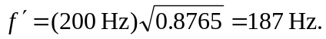

b) The water does not offer much resistance to the transverse waves in the wire, and hencethe node will be located a the point where the wire attaches to the sculpture and not at the surface of the water.

